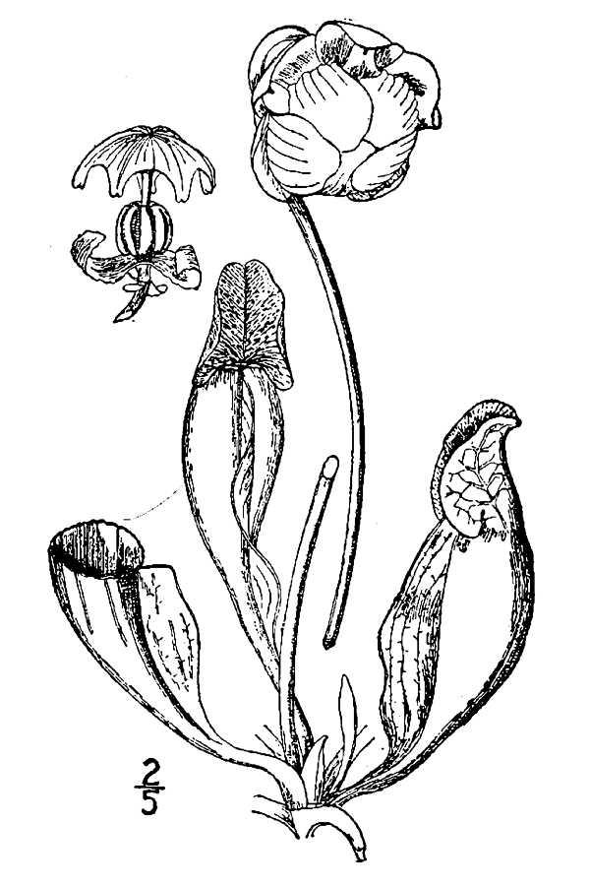
Design Plan
Advanced Floral Design

We will make five designs.

1. Print out or sketch and label a picture of a design that you would like Advanced students to make this year.

2. Determine the best time of year to make this design. When are the flowers in season and, therefore,
cheapest?

3. Make a list of all of the plant materials needed for the entire project (5 designs total working with partners).
(number, type, and color of plant materials)

4. Make a list of all of the hard goods needed for the project. (number, item number from catalog, color,
description)

5. Use the Flora Fresh price list to determine the cost of each plant material and the overall cost of plant
materials for the project. Remember, five designs total.

6. Use the Floral Supply Syndicate catalog to determine the cost of the hard goods. Include the cost of all hard
goods, not just the ones we need to buy.

7. Finally, determine the overall cost of the project and our sales price in order to make some profit.

Turn in your organized and typed proposal on ______________:

The picture/drawing of your design
List of flowers and prices
List of hard goods and prices
Overall price for the project and sales price.

Grading:

Picture/drawing clearly shows the idea 10
Flower List 10
Hard Goods List 10
Overall price/sales price 5
Organization, neatness, and clarity 10

Total Possible 45

