The Quest for Courage
The Odyssey
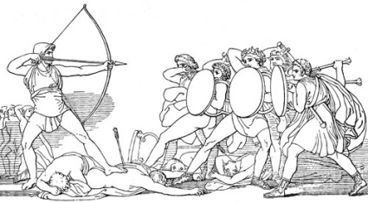
Directions:
You are Odysseus, and you must inspire your crew to be brave in the face of the next challenge. Write a motivational speech that you will deliver to the loyal men and women of your crew as they are about to risk their lives once again.

Specifics:
This is a writing assignment. Your speech should include an Introduction, Body, and Conclusion.

Introduction-

Body-

Conclusion-

Type your speech (Times New Roman font; 12 pt. font or larger)

Your speech should be 30 seconds to 2 minutes when spoken aloud. Time will be called at 2 minutes.

The Quest:
On the day that the speeches are due, your team will gather to share them with each other. As a team, you will decide on the best speech and the best speaker to present to the class. The writer and speaker do not have to be the same person. The speaker will have one day to go home and practice the speech.

On the day of the competition, the chosen speaker will deliver the speech to the class. The class will vote on the most motivating speech (teams may not vote for their own speech.) The speech with the most votes wins.

Scoring:

Your grade- 20 points (quality/effort/writing ability/clarity/length)

Quest Points- 20 points (class vote)

